Story 03 - Book Filter

## Description

As a user

I want to filter the book overview

On price, title and color

## Wireframe

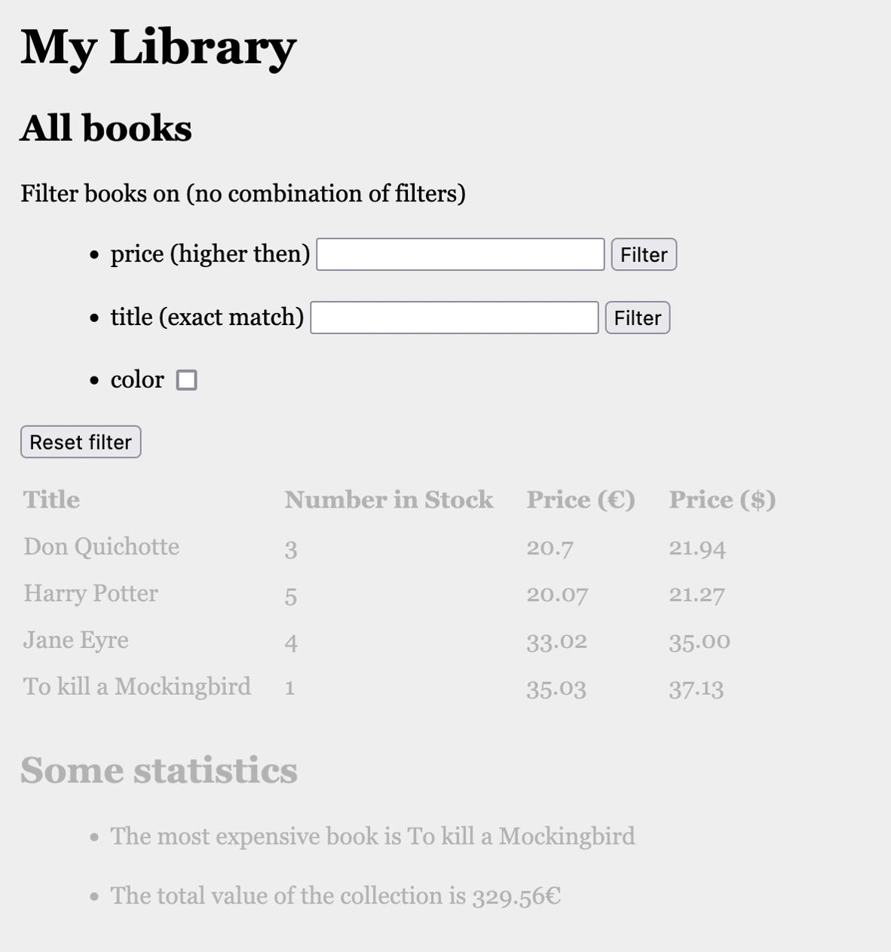

## Acceptance Criteria

* The screen shows three filter options
  1. Filter books on price: only books with price higher than given value are shown
  2. Filter books on title: only the book with the given title (exact match, not case sensitive) is shown
  3. Show only books that are in color (when check box is checked).
* Filtering only starts after clicking on the filter-button or checkbox.
* Filter values are shown in table overview
* Filters cannot be combined

## Technical Requirements

* The books are fetched from back-end by
  1. <http://localhost:8080/api/book/search/priceMoreThen?price=30>
  2. <http://localhost:8080/api/book/search/title/Jane%20Eyre>
  3. <http://localhost:8080/api/book/search/inColor>
* The response is a JSON array of books with fields “title” (String), “numberInStock” (int), “price” (double), “inColor” (Boolean), “priceInDollar” (double).